Ideation Phase

Define the Problem Statements

Date | 15 February 2026
Team ID | LTVIP2026TMIDS47425
Project Name | IntelliSQL: Intelligent SQL Querying with LLMs Using Gemini Pro
Maximum Marks | 2 Marks

Customer Problem Statement Template:
In organizations and businesses, accessing data from databases requires knowledge of SQL, which many non-technical users do not have. Writing SQL queries to retrieve reports and insights can be complex, time-consuming, and prone to errors. Users often struggle with understanding database schemas, joins, and syntax rules, making data access difficult and dependent on technical teams.
The goal of this project is to develop IntelliSQL, an intelligent system that converts natural language queries into accurate SQL statements using large language models. This system aims to simplify database interaction, reduce dependency on developers, and enable faster and more efficient data-driven decision-making.

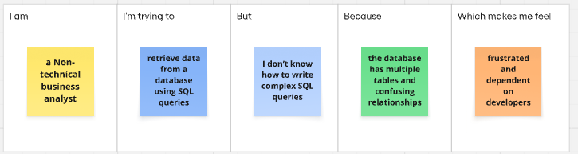

Problem  Statement (PS) | I am (Customer) | I’m trying to | But | Because | Which makes me feel
PS-1 | A non-technical business analyst | Retrieve meaningful insights from the company database | I don’t know how to write complex SQL queries | SQL syntax and database relationships are difficult to understand | Frustrated and dependent on developers
PS-2 | A data analyst working with large databases | Write accurate and optimized SQL queries quickly | Debugging errors and handling joins takes too much time | Databases contain multiple tables, constraints, and complex structures | Overwhelmed and less productive

